Addressing the energy transition challenge:
Energy storage

CSIRO actively researches the challenges associated with the transition of energy, industrial, manufacturing, agricultural and transport sectors to meet Australia’s net zero emissions ambitions.

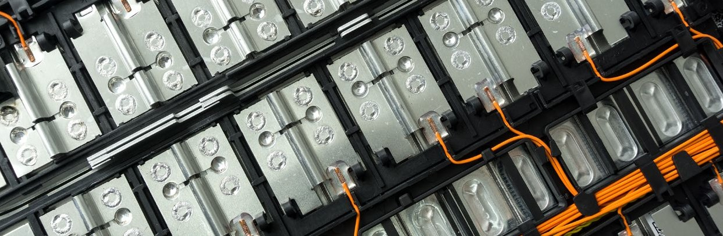

As Australia’s national science agency, CSIRO is well positioned to support governments, industries and communities through the energy transition.
Science and innovation will be critical in supporting Australia’s transition, which is being driven by new technologies, changing consumer preferences, and efforts to reduce greenhouse gas emissions.
As we move towards a net-zero emissions future the four key components of the energy sector – electricity, industry, transport and exports – are evolving rapidly. In this dynamic landscape, CSIRO provides reliable, actionable, evidence-based research.
Here we look at the role of energy storage.

Why we need energy storage solutions
The energy sector is evolving rapidly as we move towards a net-zero emissions future.
Many coal and gas resources will reach the end of their asset life over the next two decades, and by 2030 we expect that four states will be achieving at least 50% electricity generation from renewables.
However, in order to fully realise the benefits of Australia’s unmatched renewable energy sources and provide secure and affordable energy, low-cost energy storage solutions will be required.
As the generation mix changes over the coming years, we will require a range of different but complementary energy storage solutions for short and long durations that can meet the various demand of different energy sectors and provide stability and security to the electricity grid.

Australia’s National Science Agency
What are the challenges?
Australia needs an energy supply that is sustainable, affordable, and reliable. The transition of the energy sector must address these three requirements, which are referred to collectively as the energy trilemma.
A secure and reliable electricity system based on variable low emission resources is possible, and key technical challenges for ‘on demand’ availability must be addressed to reach that goal.
One key issue is intermittency – fluctuating power caused by variable wind and sun – and this requires stabilising solutions (also called firming) to ensure that we always have access to reliable, dispatchable electricity.
Energy storage technologies help fill the intermittency gap.
The Australian Government has highlighted energy storage as one of five priority low emissions technologies. In the 2020 Low Emissions Technology Statement (LETS), one of the stated stretch goals is electricity from storage for firming under
$100 per MWh.
This would enable firmed wind and solar priced at or below today’s average wholesale electricity price.
Initially, the lowest cost storage option is likely to be pumped hydro. But other storage solutions, like batteries, chemical, mechanical or thermal energy storage will become increasingly cost competitive and an important alternative in places where pumped hydro is unavailable.

What is CSIRO doing to help?
In a fast-changing landscape, CSIRO plays a crucial role in providing reliable and actionable energy research that can help Government and industry stakeholders target their investments, implement policies and adopt new technologies.
We have a long history of research on energy storage, and a number of dedicated facilities to develop and evaluate potential solutions. At our Stored Energy Integration Facility
(SEIF) and our Centre for Hybrid Energy Systems (CHES) we have the capacity to evaluate integrated batteries and develop new energy storage systems.

Current and recent work includes:
- Exploring ways to increase the capability and capacity of Australian companies to build and deploy batteries.
- A comprehensive analysis of the different types of energy storage that are being developed and where they can be best used.
- Researching the potential for Australia to value-add in the battery production chain, capitalising on our position as a world-leader in mineral production.
- Studying the potential for future energy generation and storage in Australia from the building of irrigation dams.
- Analysing the challenges and opportunities related to onshore lithium battery recycling.
- Developing a proposed Battery Storage Performance Standard.
- Delivering cost reductions and dispatchability improvements in Concentrated Solar Thermal (CST), which includes a
grid-scale storage solution.
- CSIRO is also undertaking research into direct air capture to remove carbon dioxide from the atmosphere using chemical processes. For example we developed Airthena™ that captures CO2 from ambient air and recycles it for use onsite, on-the-spot, enabling companies to generate their own supply and alleviate transportation or steam costs.
GenCost
CSIRO also collaborates with the Australian Energy Market Operator (AEMO) on GenCost.
GenCost is an annual process of updating electricity generation and storage costs. The project places a strong emphasis on stakeholder engagement as a means of supporting the quality and relevancy of outputs.
The third GenCost report (2020–21) considers the costs of storage technologies and transmission network investment that would be needed to support the different energy sources. Levelised costs of electricity (LCOEs) are also part of the report and provide a simple summary of the relative competitiveness of generation technologies.
The report shows that wind and solar will continue to be the cheapest sources of new electricity generation in Australia through to 2050, even taking into account the cost of storage and new network infrastructure.
Further reading
NREL report on Energy Storage Comparison (July 2021) https://www.nrel.gov/docs/fy21osti/76097.pdf

As Australia’s national science agency and innovation catalyst, CSIRO is solving the greatest challenges through innovative science and technology.
CSIRO. Unlocking a better future for everyone.

Contact us
1300 363 400
csiro.au/contact csiro.au

For further information
Claire Ginn
Communication Manager – Energy
+61 3 9545 2575
claire.ginn@csiro.au

OCTOBER 2021 B&M | 21-00402

